<https://wiki.hybris.com/display/release5/Available+Widgets>

<https://wiki.hybris.com/display/release4/How+to+Implement+an+Additional+Editor+-+Tutorial>

<https://wiki.hybris.com/display/release5/OMS+-+Available+Editors+Gallery>

<https://wiki.hybris.com/display/release5/Available+Editors+Gallery>

<context type=*"Comment"* component=*"customCommentaryForOrdersAndTickets"*>

<wz:flow id=*"CustomerCommentWizard"* title=*"create.title(ctx.TYPE_CODE)"*>

<wz:prepare id=*"productPrepare"*>

<wz:initialize property=*"newComment"* type=*"ctx.TYPE_CODE"*/>

</wz:prepare>

<wz:step id=*"step1"* label=*"create.comment.ticket.label"* sublabel=*"create.comment.ticket.sublabel"*>

<wz:content id=*"step1.content"*>

<wz:property-list root=*"newComment"*>

<wz:property qualifier=*"text"* editor=*"com.hybris.cockpitng.editor.defaulttext"*>

<wz:editor-parameter>

<wz:name>rows</wz:name>

<wz:value>5</wz:value>

</wz:editor-parameter>

</wz:property>

</wz:property-list>

</wz:content>

<wz:navigation id=*"step1.navigation"*>

<wz:cancel/>

<wz:done visible=*"!#empty(newComment.text)"*>

<wz:save property=*"newComment"*/>

</wz:done>

</wz:navigation>

</wz:step>

</wz:flow>

</context>

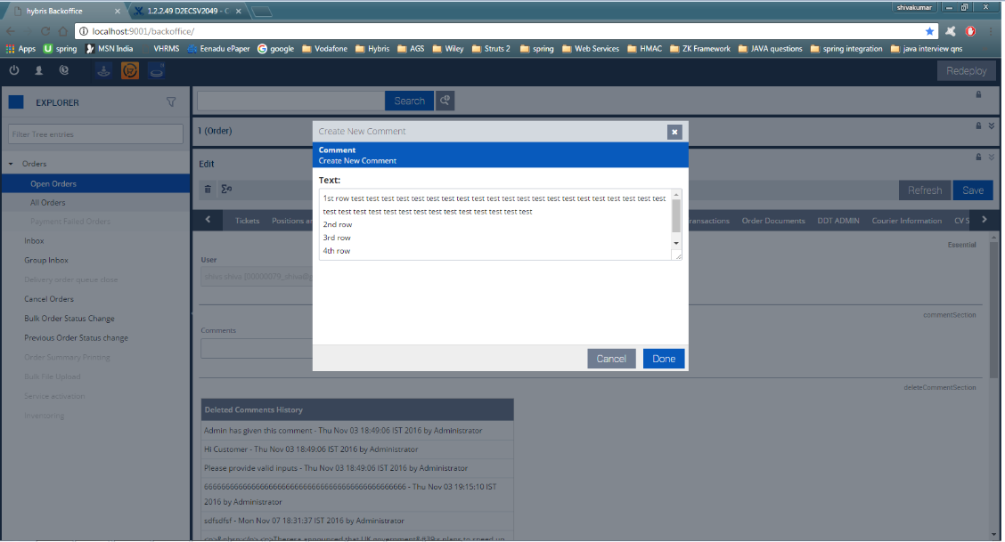

<context merge-by=*"type"* parent=*"Job"* type=*"WorkflowTemplate"* component=*"editor-area"*>

<editorArea:editorArea name=*""*>

<editorArea:essentials>

<editorArea:essentialSection name=*"hmc.essential"*>

<editorArea:attribute qualifier=*"code"* />

<editorArea:attribute qualifier=*"owner"* />

</editorArea:essentialSection>

</editorArea:essentials>

<editorArea:tab name=*"hmc.tab.workflow.properties"* position=*"1"*>

<editorArea:section name=*"hmc.section.workflow.descriptions"*>

<editorArea:attribute qualifier=*"name"* />

<editorArea:attribute qualifier=*"description"*>

<editorArea:editor-parameter>

<editorArea:name>rows</editorArea:name>

<editorArea:value>4</editorArea:value>

</editorArea:editor-parameter>

</editorArea:attribute>

</editorArea:section>

</editorArea:tab>

</editorArea:editorArea>

</context>

